Agreed by UNDP Resident Representative / UNDP Director:
Louisa Vinton  UN Resident Coordinator and  UNDP Resident Representative | Signature | Date: August 10, 2012

INITIATION PLAN
for a GEF Project Preparation Grant (PPG) or
Programme Coordination Budget (PCB)

Total budget: $ 488,818

Allocated resources:

- GEF: $ 128,818

In kind contributions:

- Government $ 360,000
Programme Period: 2012-2013
Programme Component: Energy and Environment
PPG Title: Strengthening the Institutional and Financial Sustainability of the National Protected Area System
ATLAS Project ID: 00068732
PIMS Project ID: 4731
Duration: 01/06/2012 - 30/11/2012
Management Arrangement: DIM

Country: Croatia

Relevant UNDAF Outcome(s) and Indicator(s): Croatia is non-UNDAF country.

Relevant CP/CPAP Outcome(s) and Indicator (s): Supporting Financial Sustainability of Croatian Protected Areas and ensure implementation of the CBD.

Expected Project Outcome (s) and Indicator (s):
1. PA Management Effectiveness:
1.1. A national protected area system is effectively managed by a capacitated institution leading to reduced threat of habitat destruction/fragmentation, land abandonment and overharvesting of biodiversity.
1.2. Increased management effectiveness for 19 national protected area covering 515,156 ha.
1.3. Increased capacity in national protected area agency to respond to management challenges in the 19 national protected areas.
2. PA Finance:
2.1. Croatian PA System covering 575,20 ha set on a path towards financial sustainability indicators.

Brief Description of Initiation Plan

The PPG process will engage stakeholders and will support activities that will inform the preparation of the complete project document and CEO Endorsement Request for the Full-Size Project (FSP) “Strengthening the Institutional and Financial Sustainability of the National Protected Area System”. This document will be submitted to the GEF following further information gathering and stakeholder consultation, and will be accompanied by co-financing letters in line with pledges made in the PIF. The respective partners and co-financers will be fully engaged in the project design phase; one-on-one consultations, working group meetings, and project development workshops will be convened for the purpose, as appropriate. The PPG activities will consolidate and supplement the existing information supplied in the PIF on the state of biodiversity and protected area system in Croatia. The PPG will address comments of the GEF Secretariat made at the PIF stage. The PPG activities will take into account the lessons learnt from previous UNDP-GEF projects and initiatives of other agencies and donors relevant to the subject matter of the project. The project’s technical feasibility and economic viability will be assessed, as will the risks associated with its implementation.

GEF PPG/PCB approved grant document and TBWP

(insert GEF PPG/PCB document information and TBWP here)

Project PREPARATION GRANT (ppg)
Project Type: Full-size Project
type of Trust Fund: GEF Trust Fund
Submission date: June 20, 2012

GEF Project ID: 4842
GEF Agency Project ID: 4731
Country(ies): Croatia
Project Title: Strengthening the Institutional and Financial Sustainability of the National Protected Area System
GEF Agency(ies): UNDP
GEF Focal Area(s): Biodiversity

a. Project preparation Timeframe
Start date of PPG | 01/07/2012
Completion date of PPG | 30/09/2013

B. proposed project preparation activities ($)
Describe the PPG activities and justifications:

The PPG process will engage stakeholders and will support activities that will inform the preparation of the complete project document and CEO Endorsement Request for the Full-Size Project (FSP) “Strengthening the Institutional and Financial Sustainability of the National Protected Area System”. This document will be submitted to the GEF following further information gathering and stakeholder consultation, and will be accompanied by co-financing letters in line with pledges made in the PIF. The respective partners and co-financers will be fully engaged in the project design phase; one-on-one consultations, working group meetings, and project development workshops will be convened for the purpose, as appropriate. The PPG activities will consolidate and supplement the existing information supplied in the PIF on the state of biodiversity and protected area system in Croatia. The PPG will address comments of the GEF Secretariat made at the PIF stage. The PPG activities will take into account the lessons learnt from previous UNDP-GEF projects and initiatives of other agencies and donors relevant to the subject matter of the project. The project’s technical feasibility and economic viability will be assessed, as will the risks associated with its implementation. In order to achieve these objectives, the PPG has been organized into the following activities:

PPG Activity 1. Elaborate on and analyse the ‘baseline project investments’ – with particular focus on initiatives related to PA Management and biodiversity conservation

These activities will seek to expand the description contained in the PIF. This description will need to be much more detailed at PRODOC stage. Apart from producing data on existing and planned investments that are of relevance to the project, the ancillary aim of this activity is to programme co-financing. Data to be collected includes the following:

- Collecting detailed data on the government’s investments in the environment sector in general and relating to biodiversity and PA management more specifically. Results will be broken down by type and purpose of investment, and by recipient body (including government institutions at the national and local levels). An analysis of expenditure will be undertaken (e.g. delivery/ current and near future funding situations, relative to objectives, as well as longer-term financing trends);
- Confirming data on donor-funded, non-governmental and private sector investments in the environment sector in general and in the arena of biodiversity and PA management. The information can be presented in matrix form, where the different interventions will be identified and described; the sources of funding, committed amounts in USD-equivalent and respective duration of the interventions will be documented and the key beneficiaries and implementing agents mentioned;
- Analyses of sources/types of funding for each of the protected areas making difference between the governmental source of funding, other donor funding and funding earned through diverse tourist or other activities;
- Other data points as needed.

PPG Activity 2. Review the Systemic and Institutional Structure and Capacity for Managing the System of National Protected Areas in Croatia

Preparatory activities under this activity will be directly contributing to the design of Component 1 of the proposed project and will result in the following outputs: i) information gathered and analysed on the state of protected area management in Croatia (ii) outline of a change management process for ensuring the increased effectiveness of the management of the 19 National Protected Areas of Croatia, (iii) creation of outline of barrier-removal approaches for the project to take up with respect to legal and policy gaps in PA effective management; (iv) UNDP Capacity Development Scorecard finalized. Specifically this activity will:

- Assess the current state of protection of biodiversity in the National Protected Areas of Croatia
- Review current operations and performance of the 19 Public Institutions managing 19 National Protected Areas and complete Management Effectiveness Tracking Tool for each of the 19 National Protected Areas
- Suggest a range of strategic options (at least three) in streamlining the management of the protected areas through the establishment of a National PA Agency, with cost effective centralised functions of operations, planning, information, finance and legal affairs, and effective management of 19 Protected Areas. The advantages and disadvantages of the various options should be tabled and explained as well as critiqued against future environments, financial aspects and organisational fit. Specific attention should be paid towards an analysis of how the PA Agency “Head Office” will sustain itself financially including the analysis of the proposal that the PA Agency “Head Office” should be covered by a service charge and cost-recovery system financed by the PAs. A proposed organisational structure (organigram) must be included for each strategic option.
- Based on the decision of the Government of Croatia on the preferred strategic option, develop an institutional model for the proposed National PA Agency, establish a clear mandate for the Agency and recommend the governance structure (Board) ensuring fair representation of major stakeholders to oversee its activities.
- Review the legal and policy framework for PA management and make recommendations for improvements in light of the institutional change.
- Analyze PA Management Capacity (e.g. number of staff, functions, level of training/professional development, planning, operations, enforcement, etc.), Undertake a rapid capacity assessment of staff of the 19 Public Institutions and identify critical gaps in capacity.
- Develop Terms of Reference for the development and implementation of the Staffing Plan of National PA Agency (e.g. number of staff, functions, level of training/professional development, planning, operations, enforcement, etc.), providing well-defined staff requirements and profiles. Part of the staffing plan should include staff career advancement and training plans and the development of a performance-based promotion system.
- Assess staff salaries and incentives for PA and proposed National PA Agency staff including incentives for enforcement activities;
- Compile on the basis of the above the UNDP Capacity Development Scorecard.
- Assessment of the financial management and training needs for the PA managers of the Croatia’s national PA System. This includes a review of existing financial projection methods and procedures, cost accounting and reporting, coordination with the management effectiveness support process being developed under Component 1.
- Assessment of existing data systems and their integration with the PA Management Information System.
- Develop Terms of Reference for the development of a Protected Area Management Information System which includes modules for financial and management accounting, environmental management, administration, and ability to integrate other modules in the future.

PPG Activity 3: Detailed Assessment of PA Financing and Legal Environment in the Area of PA Financing

Preparatory activities under this activity will be directly contributing to the design of Component 2 of the proposed project and will result in the following outputs: i) information gathered and analyzed on the state of funding of current PA system (ii) barrier-removal approaches with respect to legal and policy gaps in PA financing are outlined; (iii) UNDP/GEF Financial Scorecard is finalized. Specifically, the preparatory activities under this component will include an assessment of:

- Assess available information on Protected Area financing: central budget allocations, regional budgets (if any), external donor funding; income generated and retained by PAs (broken down by source – tourism, entrance fees, concessions others)
- Obtain information for the assessment of needed financing for the NPA system: basic operating and investment costs, estimated needs for optimal management of protected areas and their biodiversity. Identify the financing gap.
- Review the resource needs of the existing PAs and the proposed central PA Agency, status of PA Infrastructure (e.g. roads, buildings, fences, equipment, vehicles, computers, GPS, etc.)
- Analysis of existing legal and regulatory frameworks (and gaps) for PA financing;
- Assess current macro-level fiscal instruments such as taxes on tourism and water and tax incentives – and whether these can be earmarked specifically for protected areas.
- Identify ways to optimize PA expenditure (to rationalise it based on cost-effectiveness of site management and ecological importance of sites);
- Analyse the roles of national NGO, CPIs and private sector in PA financing and provide suggestions for their involvement;
- Assess the current fee-setting procedure: how PA set fees/charges in tourism, regulated hunting, recreation, catering etc.
- Compile on the basis of the above and information gathered under the other Activities of the PPG the UNDP/GEF Financial Scorecard;
- Develop Terms of Reference for specialists that will be involved in the drafting of the five-year National Park Agency Strategic and Business Plan.

PPG Activity 4: Feasibility Studies and Pilots for various revenue-generation and cost optimization options at PA and site levels:

These activities are key for defining the revenue generation and cost optimization strategy and specifics of Component 2 of the proposed FSP. The outputs will be: (i) extended checklist of existing and potential revenue mechanisms for the NPA, their strengths and weaknesses; (ii) Preparation of TOR for economic valuation of resources and ecosystem functions; (iii) Procedures and agreements obtained for revenue-generating pilots (iv) project strategy clarified for Component 2, in terms of what mechanisms can be best demonstrated at what sites.

Specifically, this component will:

- Preparation of list of existing and potential revenue mechanisms for the NPA, their strengths and weaknesses and opportunities; Development of TOR including methodologies for the economic valuation studies to be conducted for the national PA system. Criteria for methodology will be based on 1) best available practices 2) comparability with other economic valuation studies conducted in the South-East Europe or on similar ecosystems; 3) focus on use values but including non-use values as well and 4) cost-effectiveness of methods.
- Determine through discussion with the Ministry and other stakeholders the income-generation and cost-optimisation pilots that will be implemented by the project. The Government and UNDP have tentatively been investigating the PES opportunities. Tentative ideas include a payment for ecosystem services schemeto be piloted for water provision services in the Velebit PA complex (Northern Velebit National Park and Velebit Nature Park, and the income of user fees for nature-based tourism is raised in the Lonjsko polje Nature Park and Plitvice Lakes National Park. During the PPG, however, a much broader scope of PES opportunities is going to be considered. For that, the PPG will do a thorough analysis of sites and revenue mechanisms, potential buyers and purchasers, and other parameters of PES deals. Therefore, the ideas provided above are tentative and not exclusive. The final income-generation innovations and infrastructure to be established will be determined as a result of the PPG phase, and the submission documents will contain clear description of (1) location of sites where PES will be implemented, (2) revenue generation mechanism in question, (3) potential buyers and provider of service, price and other parameters of PES implementation.
- Develop criteria for site selection and agree with key stakeholders on at least five protected areas where the selected approaches will be piloted. Fair ecological representation should be considered when selecting the pilot sites.
- Develop terms of reference for the development of 5 site business plans.

PPG Activity 5. Feasibility and risk analysis, strategy development and budget

The specific activities include:
- Undertake a detailed incremental cost-analysis of the proposed project through the definition and costing of the baseline projects versus the activities and costing of those activities that will be needed to achieve the proposed project’s goal, also taking account of the co-financing that will be leveraged during the implementation of the project. The end result should be a definition of the project’s incremental value over the period of implementation, described in a matrices format.
- Describe and evaluate any alternative means of achieving the goals of the project. Cost the alternative approaches and through the process strengthen the cost-effectiveness argument of the project.
- Defining an overall Monitoring and Evaluation Framework for the project that will ensure the project achieves it objectives and outcomes and that the project stays on track during implementation. This will include an evaluation of current M&E systems used by the different stakeholders in Croatia to measure impacts on biodiversity and impacts of conservation actions. Stakeholders should be consulted on the M & E framework to ensure their buy-in and agreement in order to increase the possibility of the project achieving and exceeding its goals, but also to ensure that it is realistic and achievable.
- Based on all the above activities, finalise the implementing strategy for the project detailing the inputs required for implementation (consultant/contracts and their terms of reference [ToRs] – equipment, travel, etc.), and developing a financing plan.

List of Proposed Project Preparation Activities | Output of the PPG Activities | Trust Fund | Grant Amount (a) | Co-financing (b) | Total  c = a + b
Activity 1. Elaborate on and analyse the ‘baseline project investments’ – with particular focus on initiatives related to PA Management and biodiversity conservation | - Baseline project investments with respect to the environment and biodiversity/PA management are duly assessed and trends analyzed.  - The global significance argument is made for Croatia. | GEFTF | 25,200 | 70,422 | 95,622
Activity 2: Review the Systemic and Institutional Structure and Capacity for Managing the System of National Protected Areas in Croatia | - Information gathered and analysed on the state of PA management in Croatia.  - Outline of a change management process for ensuring the increased effectiveness of the management of the 19 national PAs of Croatia.  - Creation of outline of barrier-removal approaches for the project to take up with respect to legal and policy gaps in PA effective management.  - UNDP Capacity Development Scorecard.  - an outline of the installation and operationalisation on a PA Management Information System which includes modules for financial and management accounting, environmental management, administration, and ability to integrate other modules in the future.  - the completion of the METT for the 19 national Protected Areas. | GEFTF | 45,200 | 126,422 | 171,622
Activity 3: Detailed Assessment of the Policy and Legal Environment in the Area of PA Financing | - Information gathered and analyzed on the state of funding of current PA system  - Outline of barrier-removal approaches for the project to take up with respect to legal and policy gaps in PA sustainable financing;  - UNDP/GEF Financial Scorecard finalized. | GEFTF | 20,200 | 56,422 | 76,622
Activity 4: Feasibility Studies and Pilots for Various Revenue-generation and Cost Optimization Options at PA’s and Site Levels | - Extended checklist of all current and potential revenue mechanisms for PAs, their weaknesses and opportunities;  - Brief economic valuation of resources and ecosystem functions carried out;  - Procedures and agreements obtained for revenue-generating pilots  - Project strategy clarified for Component 2, in terms of what mechanisms can be best demonstrated at what sites. | GEFTF | 25,200 | 70,422 | 95,622
Activity 5: Feasibility Analysis and Budget | The project strategy, its detailed costing and incremental reasoning take shape. | GEFTF | 13,018 | 36,312 | 49,330
Total Project Preparation Financing |  |  | 128,818 | 360,000 | 488,818

C. Financing plan summary for project preparation grant: ($)
 | Project Preparation | Agency Fee
Grant Amount | 128,818 | 12,882
Co-financing | 360,000
Total | 488,818 | 12,882

D. PPG Amount requested by agency(ies), focal area(s) and country(ies) ¹
Trust Fund | GEF Agency | Focal Area | Country Name/  Global | (in $)
 |  |  |  | PPG (a) | Agency  Fee (b) | Total  c = a + b
GEF TF | UNDP | Biodiversity | Croatia | 128,818 | 12,882 | 141,700
Total PPG Amount |  |  |  | 128,818 | 12,882 | 141,700
¹ No need to provide information for this table if it is a single focal area, single country and single GEF Agency project.
E. PPG Budget
Cost Items | Total Estimated Person Weeks for Grant (PW) | Grant Amount ($) | Co-financing ($) | Total($)
Local consultants * | 58 | 60,900 | 238,699 | 299,599
International consultants* | 12 | 36,000 | 0,00 | 36,000
Travel** |  | 21,600 | 80,087 | 101,687
Workshops and consultation*** |  | 10,318 | 41,214 | 51,532
Total PPG Budget |  | 128,818 | 360,000 | 488,818
* Annex A for Consultant cost details should be prepared first before completing this table. See notes on Annex A for the
required detailed information. This table is the sum of all local and international consultants presented in Annex A.
** Travel costs: Travel cost will cover: a) local travel for consultants to PAs (cost for terrestrial travel and per diems); and b) travel to Croatia and per diems for international project development and PA management expert.
*** Miscellaneous cost under co-financing covers cash and in-kind contributions from project partners (i.e., Government and NGOs) associated with PPG management and administrative costs including: contracting of consultant and follow-up; participation of staff in project design; document translation; office space and equipment; and financial management and reporting. Workshop costs include a PPG inception workshop and consultation meetings with multiple stakeholders for project formulation.

F. GEF Agency(ies) Certification
This request has been prepared in accordance with GEF policies and procedures and meets the GEF Trust Fund criteria for project identification and preparation.
Agency Coordinator, Agency Name | Signature | Date  (Month, day, year) | Project Contact Person | Telephone | Email Address
Yannick Glemarec, Executive Coordinator,  UNDP/GEF |  | June 20, 2012 | Johan Robinson, Regional Technical Advisor for Biodiversity, Europe and CIS, UNDP | +421  259337299 | johan.robinson@undp.org

Annex A

Consultants Financed by the Project Preparation Grant (PPG)

Type of Consultant | Position / Titles | $/  Person Week¹ | Estimated PWs² | Tasks to be Performed
International | PA Systems/Institutional Strengthening Specialist | 3000 | 12 | The specialist will serve as team leader in collating inputs of different team specialists and take the lead in collaboration with key stakeholders, implementing and executing agencies in designing the full project document. The work involves facilitating the following process:  - Reviewing of operational strategies and resource needs, and providing support for effective project design,  - Providing an overall orientation to the PPG team in relation to GEF requirements for project planning and monitoring,  - Recommend priority activities to be covered under the project in support of strengthening the PA management system, and suggest appropriate indicators with baseline information;  - Ensure full stakeholder consultation so as to ensure project ownership and full participation in implementation through generating buy-in on the project contents;  - Together with the Finance Management Specialist and Institutional Capacity Development Specialist, suggest a range of strategic options (at least three) in streamlining the management of the protected areas through the establishment of a National PA Agency, with cost effective centralised functions of operations, planning, information, finance and legal affairs, and effective management of 19 Protected Areas.  - Together with the Finance Management Specialist and Institutional Capacity Development Specialist, develop an institutional model for the proposed National PA Agency and recommend a governance structure.  - Provide case studies of international experiences in relation to the establishment of a central PA management agency that would be responsible for the management of the national system of protected areas in Croatia, identifying contradictions or critical gaps which may hamper the progress of implementation, and suggest measures to remove the barriers;  - Provide guidance and inputs for local experts  - Review baseline information delivered by the local experts;  - Develop the threats and root causes matrix, and the description of the barriers to the effective management of the national PAs;  - Carry out an incremental analysis and cost effectiveness analysis of the project strategy;  - Assess the sustainability of suggested project outcomes and outputs;  - Assess global environmental benefits sought from the project;  - Propose a project monitoring and evaluation framework with a set of measurable impact and progress indicators;  - Ensure the quality of capacity development scorecard assessments;  - Ensure linkages with other government, donor and GEF PA Biodiversity projects in the region;  - Take the lead in collating the inputs of different team specialists and draft the full project document and CEO request. Revise as necessary to satisfy all parties.
Local | Finance Management Specialist/Economist | 1050 | 30 | The Finance Management Specialist will act as the lead national consultant to ensure generation of necessary information for project formulation.  The financial management specialist will:  - Defining operational strategies and resource needs, and providing administrative support for effective project design,  - Conduct the Financial Sustainability Scorecard Assessment at the national level for national PA system management with accurate assessment of currently available PA revenue and budget and clear identification of financing gaps and opportunities for increasing financing;  - Together with the PA Systems/Institutional Strengthening Specialist and Institutional Capacity Development Specialist, suggest a range of strategic options (at least three) in streamlining the management of the protected areas through the establishment of a National PA Agency, with cost effective centralised functions of operations, planning, information, finance and legal affairs, and effective management of 19 Protected Areas.  - Together with the PA Systems/Institutional Strengthening Specialist and Institutional Capacity Development Specialist, develop an institutional model for the proposed National PA Agency and recommend a governance structure.  - Develop budget plans for the project;  - Develop recommended activities to be covered under the project in support of strengthening the PA management system;  - Assess staffing levels and current levels of competence; identify staff recruitment needs;  - Do the assessment of park sites to determine pilot projects with respect to revenue generation and cost optimisation of NP and PPs in order to increase financial sustainability  - Assist in assessment of park sites to determine baseline project for investment in order to increase financial sustainability of National PAs  - Determine key equipment or infrastructure that should be provided under GEF funding and co-financing.
Local | PA Management Specialist | 1050 | 15 | PA Management specialist will:  - Provide technical input pertaining to protected area planning and management in Croatia;  - Ensure the accuracy of indicator baselines with clear methodologies for monitoring, as well as the feasibility of targets for the project;  - Conduct necessary Management Effectiveness Tracking Tool (METT) assessment for each of the 19 NPA’s;  - Evaluate current levels of management effectiveness of stakeholder agencies for core operations essential for good governance and management of key national PAs - using METT score sheets to establish baseline and targets for the project;  - Providing methodological guidance for data collection related to project planning and monitoring with particular attention given to the description and quantification of the baseline investments;  - Assist team leader to organise stakeholder consultation sessions in order to solicit inputs and ensure stakeholder involvement in and buy-in to the project,
Local | Institutional Capacity Development Specialist | 1050 | 13 | The specialist will undertake detailed analysis on institutional structure and capacity at the national level for managing the system of national PAs, including:  - A detailed profile and institutional analysis of Public Institutions managing Protected Areas, with clear roles in project implementation, based on a thorough assessment using the capacity scorecards;  - Overview and providing of inputs for improvement of the final national agreed governance and institutional structures at the national level including planning, decision making and budgeting processes;  - Together with the PA Systems/Institutional Strengthening Specialist and Finance Management Specialist, suggest a range of strategic options (at least three) in streamlining the management of the protected areas through the establishment of a National PA Agency, with cost effective centralised functions of operations, planning, information, finance and legal affairs, and effective management of 19 Protected Areas.  - Together with the PA Systems/Institutional Strengthening Specialist and Finance Management Specialist, develop an institutional model for the proposed National PA Agency and recommend a governance structure.  - Analysis and recommendations for institutional/agency capacity development activities to strengthen their PA system planning and management capacity and coordination between the different Public Institutions;  - Develop Terms of Reference for the development of a detailed business and strategic plan for the selected strategic option of the national PA Agency  - Recommendation for the implementation arrangements for the project;  - Analyze the training needs for a central PA agency as well as the those of the existing PIs that amalgamated into the new agency, and in particular the main technical capacity gaps in protected area management;  - Develop a career development plan for employees who will address promotion, transfer, incentives, training and performance issues.
¹ Provide dollar amount per person week.
² Provide person weeks needed to carry out the task

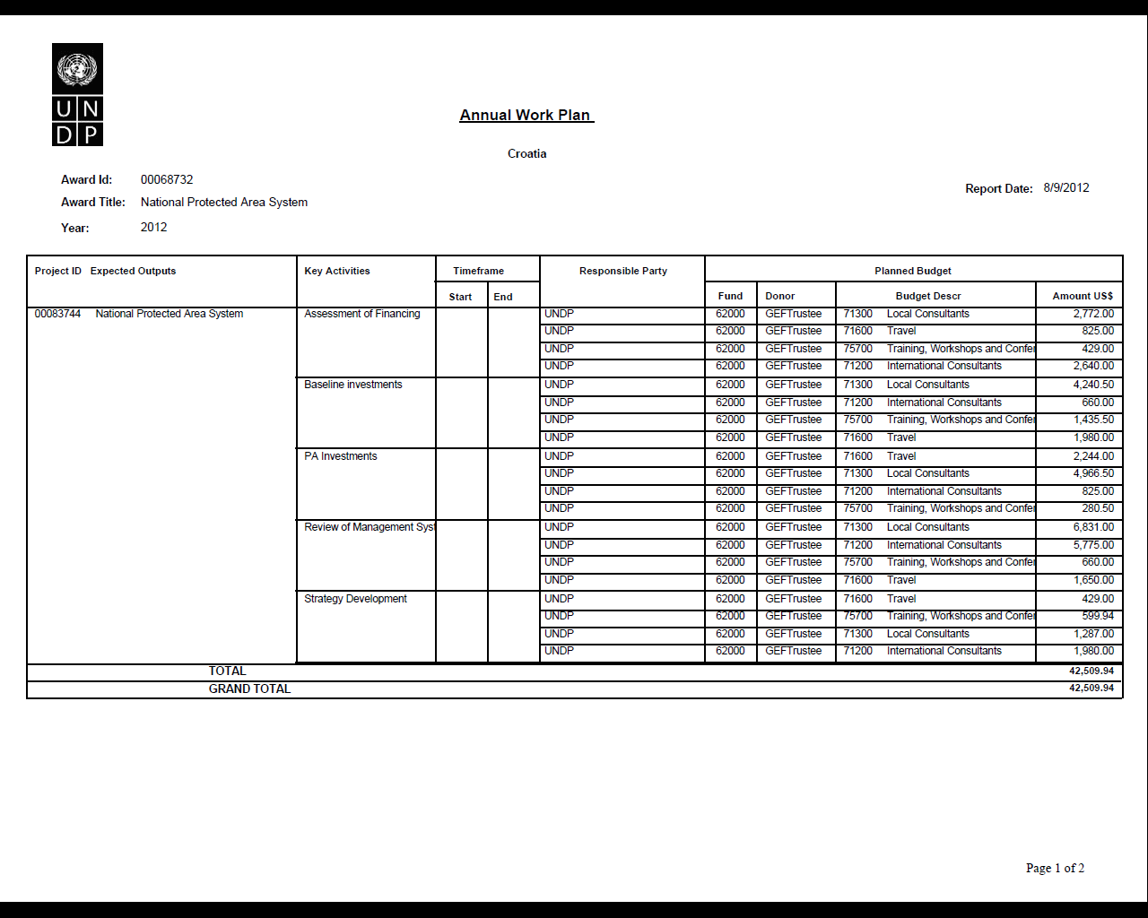
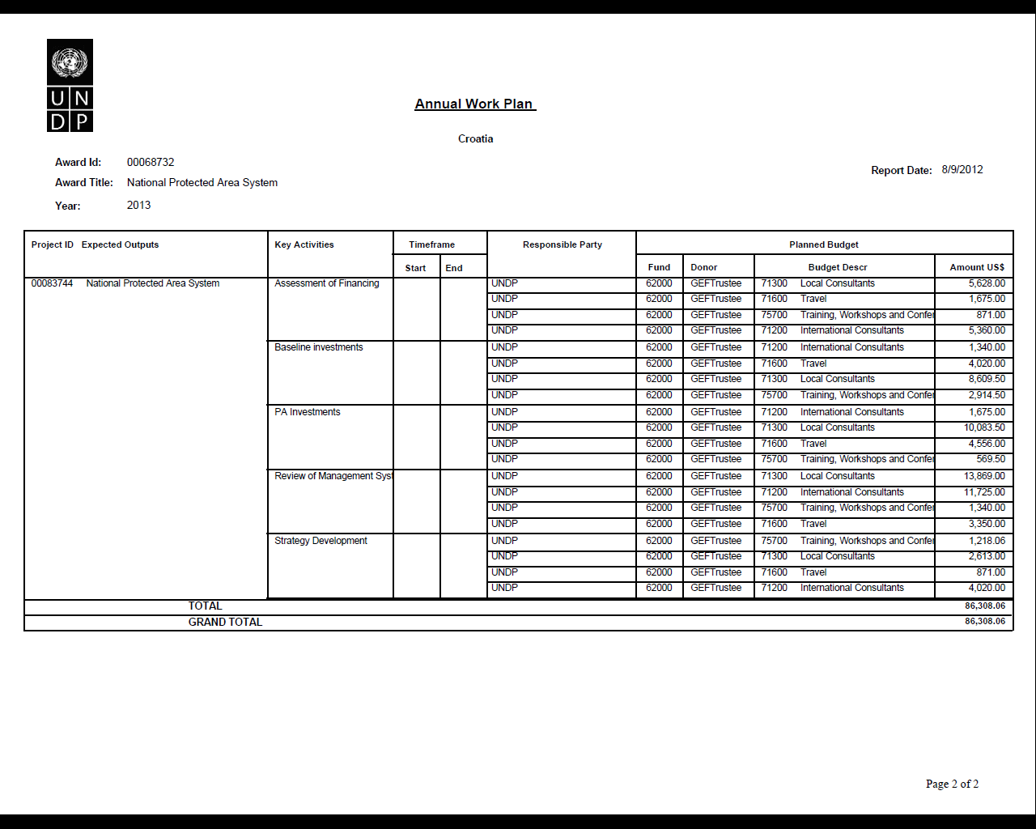

A key criterion for the institutional set-up will be the financial sustainability of the PA system. In designing the financing of the “Head Office” approach, there should be a focus on ensuring improved efficiencies and performance, including in financial sustainability terms, against the baseline.
The possible implementation and effectiveness of a PES system should be investigated during the PPG phase as limited funds are available for this financial mechanism.

